PIRATE CHARACTER’S NAMES | 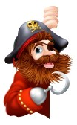
Pineapple Poll p2 Gentleman Jake p4 Bloodeye Bill p4 Doubloon Donna the Dangerous p4
Flat-Foot Fred p10 Scarface Stan p10
Captain Cowell p16 Sharkbite Sharon p16
Peg-Leg Louis p16 Pistol Pedro p16
Mad Mason p100 Jago Sparke p105
Captain Cutlass p1 Abel Monkshood p107
Fidget p120 Dastardly Des p121
Captain Whiskers p123 Pablo Pesos p129

PIRATE POSSESSION NAMES | 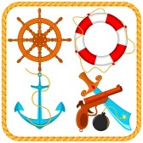
Gunbarrel Grog p5 Swag Snacks p5
Black Spot Bugle p4 Make Me Hearty medicine p13
PIRATE SHIP’S NAMES | 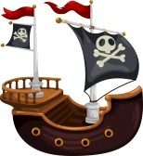
Blue Moon p1 Fair Spanish Lady p16
Demon Dragon p17 Saucy Sue p17
Firebird p105 Slinky Susan p121

PIRATE LOCATION NAMES | 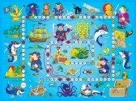
Scurvy Dog Inn p4 Dead Man’s Bay p7
Davy Jones’s locker p10

WELL KNOWN PIRATE  PHRASES  [see 237 – 239 for many more] | 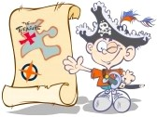
‘You ugly bunch of barnacles!’ p1
‘You useless load of landlubbers!’ p14
‘Well, splice the main brace and shiver me timbers!’ p134

